[Which Exchange version am I using?](https://www.msoutlook.info/question/277" \o "Permanent Link to Which Exchange version am I using?)

I’ve read about several features I liked but they depend on the version of Exchange I am connecting to.

Aside from contacting my mail admin, how can I found out which version of Exchange I’m running against?

There is an option to check your connection status which also displays the Exchange version number.

1. Start Outlook and connect to the Exchange server if this isn’t done automatically already.
2. Hold CTRL while clicking on the Outlook icon in the Notification Area  
   (located in the right bottom area near the time; expand the Notification Area first if the Outlook icon does not show).
3. From the context menu that pops-up choose: Connection Status…

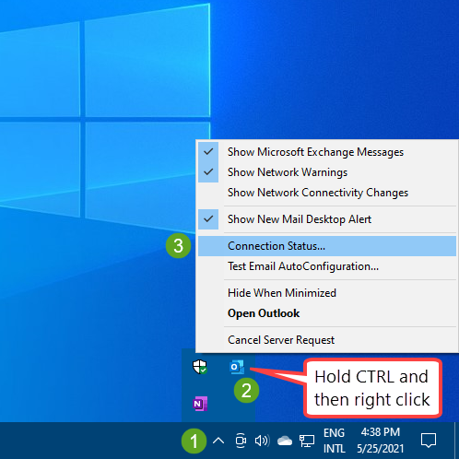

1. Scroll the horizontal scrollbar to the right to see the last column.  
   (if the dialog is empty, then you are not connected to Exchange)
2. Here you’ll see a version number. Use the table below to determine which named version of Exchange it corresponds with.  
   Your version number could be between 2 named versions. In that case, your named version corresponds with the lower version but with some additional update installed.

[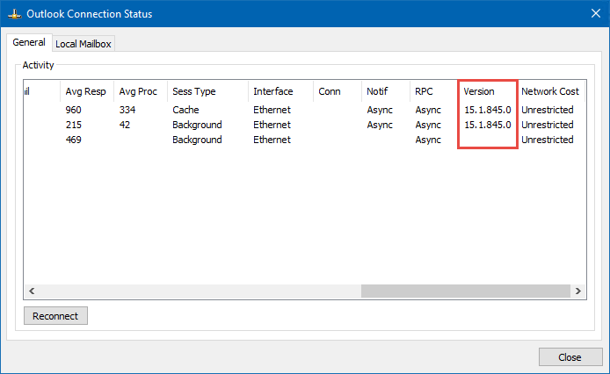](https://www.msoutlook.info/pictures/connection-status-version.png)

|  |  |
| --- | --- |
| **Microsoft 365 Exchange Online and Outlook.com** | **15.20.###.#** |
|  |  |
| **Microsoft Exchange Server 2019** | **15.2.221.12** |
| Microsoft Exchange Server 2019 CU1 | 15.2.330.5 |
| Microsoft Exchange Server 2019 CU2 | 15.2.397.3 |
| Microsoft Exchange Server 2019 CU3 | 15.2.464.5 |
| Microsoft Exchange Server 2019 CU4 | 15.2.529.5 |
| Microsoft Exchange Server 2019 CU5 | 15.2.595.3 |
| Microsoft Exchange Server 2019 CU6 | 15.2.659.4 |
| Microsoft Exchange Server 2019 CU7 | 15.2.721.2 |
| Microsoft Exchange Server 2019 CU8 | 15.2.792.3 |
| Microsoft Exchange Server 2019 CU9 | 15.2.858.5 |
| Microsoft Exchange Server 2019 CU10 | 15.2.922.7 |
|  |  |
| **Microsoft Exchange Server 2016** | **15.1.225.42** |
| Microsoft Exchange Server 2016 CU1 | 15.1.396.30 |
| Microsoft Exchange Server 2016 CU2 | 15.1.466.34 |
| Microsoft Exchange Server 2016 CU3 | 15.1.544.27 |
| Microsoft Exchange Server 2016 CU4 | 15.1.669.32 |
| Microsoft Exchange Server 2016 CU5 | 15.1.845.34 |
| Microsoft Exchange Server 2016 CU6 | 15.1.1034.26 |
| Microsoft Exchange Server 2016 CU7 | 15.1.1261.35 |
| Microsoft Exchange Server 2016 CU8 | 15.1.1415.2 |
| Microsoft Exchange Server 2016 CU9 | 15.1.1466.3 |
| Microsoft Exchange Server 2016 CU10 | 15.1.1531.3 |
| Microsoft Exchange Server 2016 CU11 | 15.1.1591.10 |
| Microsoft Exchange Server 2016 CU12 | 15.1.1713.5 |
| Microsoft Exchange Server 2016 CU13 | 15.1.1779.2 |
| Microsoft Exchange Server 2016 CU14 | 15.1.1847.3 |
| Microsoft Exchange Server 2016 CU15 | 15.1.1913.5 |
| Microsoft Exchange Server 2016 CU16 | 15.1.1979.3 |
| Microsoft Exchange Server 2016 CU17 | 15.1.2044.4 |
| Microsoft Exchange Server 2016 CU18 | 15.1.2106.2 |
| Microsoft Exchange Server 2016 CU19 | 15.1.2176.2 |
| Microsoft Exchange Server 2016 CU20 | 15.1.2242.4 |
| Microsoft Exchange Server 2016 CU21 | 15.1.2308.8 |
|  |  |
| **Microsoft Exchange Server 2013** | **15.0.516.32** |
| Microsoft Exchange Server 2013 CU1 | 15.0.620.29 |
| Microsoft Exchange Server 2013 CU3 | 15.0.712.24 |
| Microsoft Exchange Server 2013 CU3 | 15.0.775.38 |
| Microsoft Exchange Server 2013 SP1 (CU4) | 15.0.847.32 |
| Microsoft Exchange Server 2013 CU5 | 15.0.913.22 |
| Microsoft Exchange Server 2013 CU6 | 15.0.995.29 |
| Microsoft Exchange Server 2013 CU7 | 15.0.1044.25 |
| Microsoft Exchange Server 2013 CU8 | 15.0.1076.9 |
| Microsoft Exchange Server 2013 CU9 | 15.0.1104.5 |
| Microsoft Exchange Server 2013 CU10 | 15.0.1130.7 |
| Microsoft Exchange Server 2013 CU11 | 15.0.1156.6 |
| Microsoft Exchange Server 2013 CU12 | 15.0.1178.4 |
| Microsoft Exchange Server 2013 CU13 | 15.0.1210.3 |
| Microsoft Exchange Server 2013 CU14 | 15.0.1236.3 |
| Microsoft Exchange Server 2013 CU15 | 15.0.1263.5 |
| Microsoft Exchange Server 2013 CU16 | 15.0.1293.2 |
| Microsoft Exchange Server 2013 CU17 | 15.0.1320.4 |
| Microsoft Exchange Server 2013 CU18 | 15.0.1347.2 |
| Microsoft Exchange Server 2013 CU19 | 15.0.1365.1 |
| Microsoft Exchange Server 2013 CU20 | 15.0.1367.3 |
| Microsoft Exchange Server 2013 CU21 | 15.0.1395.4 |
| Microsoft Exchange Server 2013 CU22 | 15.0.1473.3 |
| Microsoft Exchange Server 2013 CU23 | 15.0.1497.2 |
|  |  |
| **Microsoft Exchange Server 2010** | **14.0.639.21** |
| Microsoft Exchange Server 2010 SP1 | 14.1.218.15 |
| Microsoft Exchange Server 2010 SP2 | 14.2.247.5 |
| Microsoft Exchange Server 2010 SP2 RU4 | 14.2.318.2 |
| Microsoft Exchange Server 2010 SP3 | 14.3.123.4 |
| Microsoft Exchange Server 2010 SP3 RU11 | 14.3.266.1 |
| Microsoft Exchange Server 2010 SP3 RU12 | 14.3.279.2 |
| Microsoft Exchange Server 2010 SP3 RU13 | 14.3.294.0 |
| Microsoft Exchange Server 2010 SP3 RU14 | 14.3.301.0 |
| Microsoft Exchange Server 2010 SP3 RU15 | 14.3.319.2 |
| Microsoft Exchange Server 2010 SP3 RU16 | 14.3.339.0 |
| Microsoft Exchange Server 2010 SP3 RU17 | 14.3.352.0 |
| Microsoft Exchange Server 2010 SP3 RU18 | 14.3.361.1 |
| Microsoft Exchange Server 2010 SP3 RU19 | 14.3.382.0 |
| Microsoft Exchange Server 2010 SP3 RU20 | 14.3.389.1 |
| Microsoft Exchange Server 2010 SP3 RU21 | 14.3.399.2 |
| Microsoft Exchange Server 2010 SP3 RU22 | 14.3.411.0 |
| Microsoft Exchange Server 2010 SP3 RU23 | 14.3.417.1 |
| Microsoft Exchange Server 2010 SP3 RU24 | 14.3.419.0 |
| Microsoft Exchange Server 2010 SP3 RU25 | 14.3.435.0 |
| Microsoft Exchange Server 2010 SP3 RU26 | 14.3.442.0 |
| Microsoft Exchange Server 2010 SP3 RU27 | 14.3.452.0 |
| Microsoft Exchange Server 2010 SP3 RU28 | 14.3.461.1 |
| Microsoft Exchange Server 2010 SP3 RU29 | 14.3.468.0 |
| Microsoft Exchange Server 2010 SP3 RU30 | 14.3.496.0 |
| Microsoft Exchange Server 2010 SP3 RU31 | 14.3.509.0 |
| Microsoft Exchange Server 2010 SP3 RU32 | 14.3.513.0 |
|  |  |
| **Microsoft Exchange Server 2007** | **8.0.685.24** |
| Microsoft Exchange Server 2007 SP1 | 8.1.240.6 |
| Microsoft Exchange Server 2007 SP2 | 8.2.176.0 |
| Microsoft Exchange Server 2007 SP3 | 8.3.83.0 |
| Microsoft Exchange Server 2007 SP3 RU23 | 8.3.517.0 |
|  |  |
| **Microsoft Exchange Server 2003** | **6.5.6944** |
| Microsoft Exchange Server 2003 SP1 | 6.5.7226 |
| Microsoft Exchange Server 2003 SP2 | 6.5.7638 |
|  |  |
| **Microsoft Exchange Server 2000** | **6.0.4417** |
| Microsoft Exchange Server 2000 SP1 | 6.0.4712 |
| Microsoft Exchange Server 2000 SP2 | 6.0.5762 |
| Microsoft Exchange Server 2000 SP3 | 6.0.6249 |